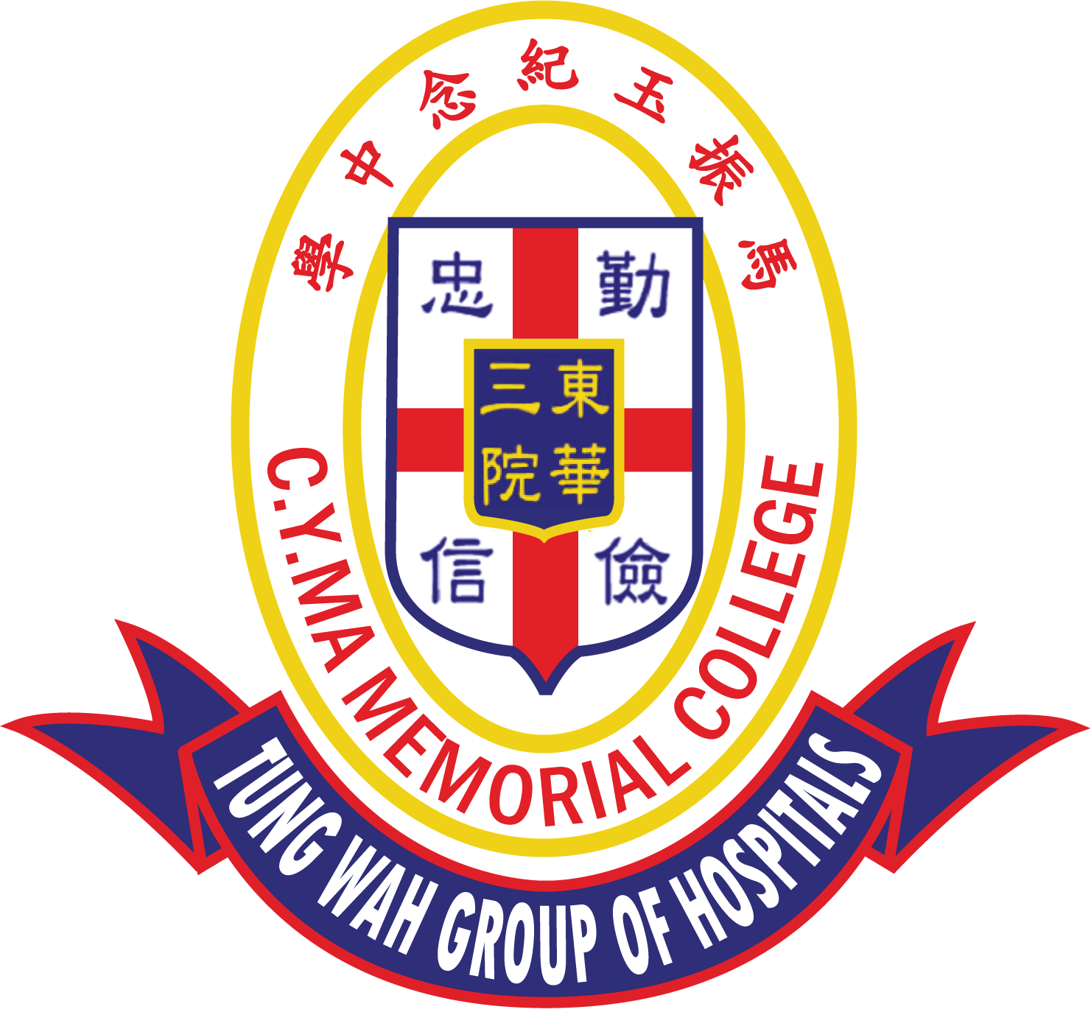
TWGHs C.Y. Ma Memorial College
The 6th C.Y. Ma Culture and Arts Youth Elites Tournament
English Penmanship Competition
Application Form

A. School Particulars

School Name | English
 | Chinese
School Address
School Telephone |  |  | School Fax |  | Teacher’s Contact Number
Teacher’s Name |  |  |  | Teacher’s Email

B. Information of the Students

Student’s Particulars |  |  | Class | For Official Use
1 | Student’s Name | English
 |  | Chinese
2 | Student’s Name | English
 |  | Chinese
3 | Student’s Name | English
 |  | Chinese

C. Remarks:
- Complete and return this application form and entry form(s) to the school [Address: 3 Yau Shin Street, Au Tau, Yuen Long, N.T. (English Section)] by post on or before 17th February 2023 (Friday).
- Notification of the shortlisted contestants will be received on or before 24th February 2023 (Friday) by email.
- Please contact Miss Mabel Lam on 2443 9833 for enquiries.

School Chop

Principal’s Name:

Principal’s Signature:

Date:

