TWGHs C. Y. Ma Memorial College
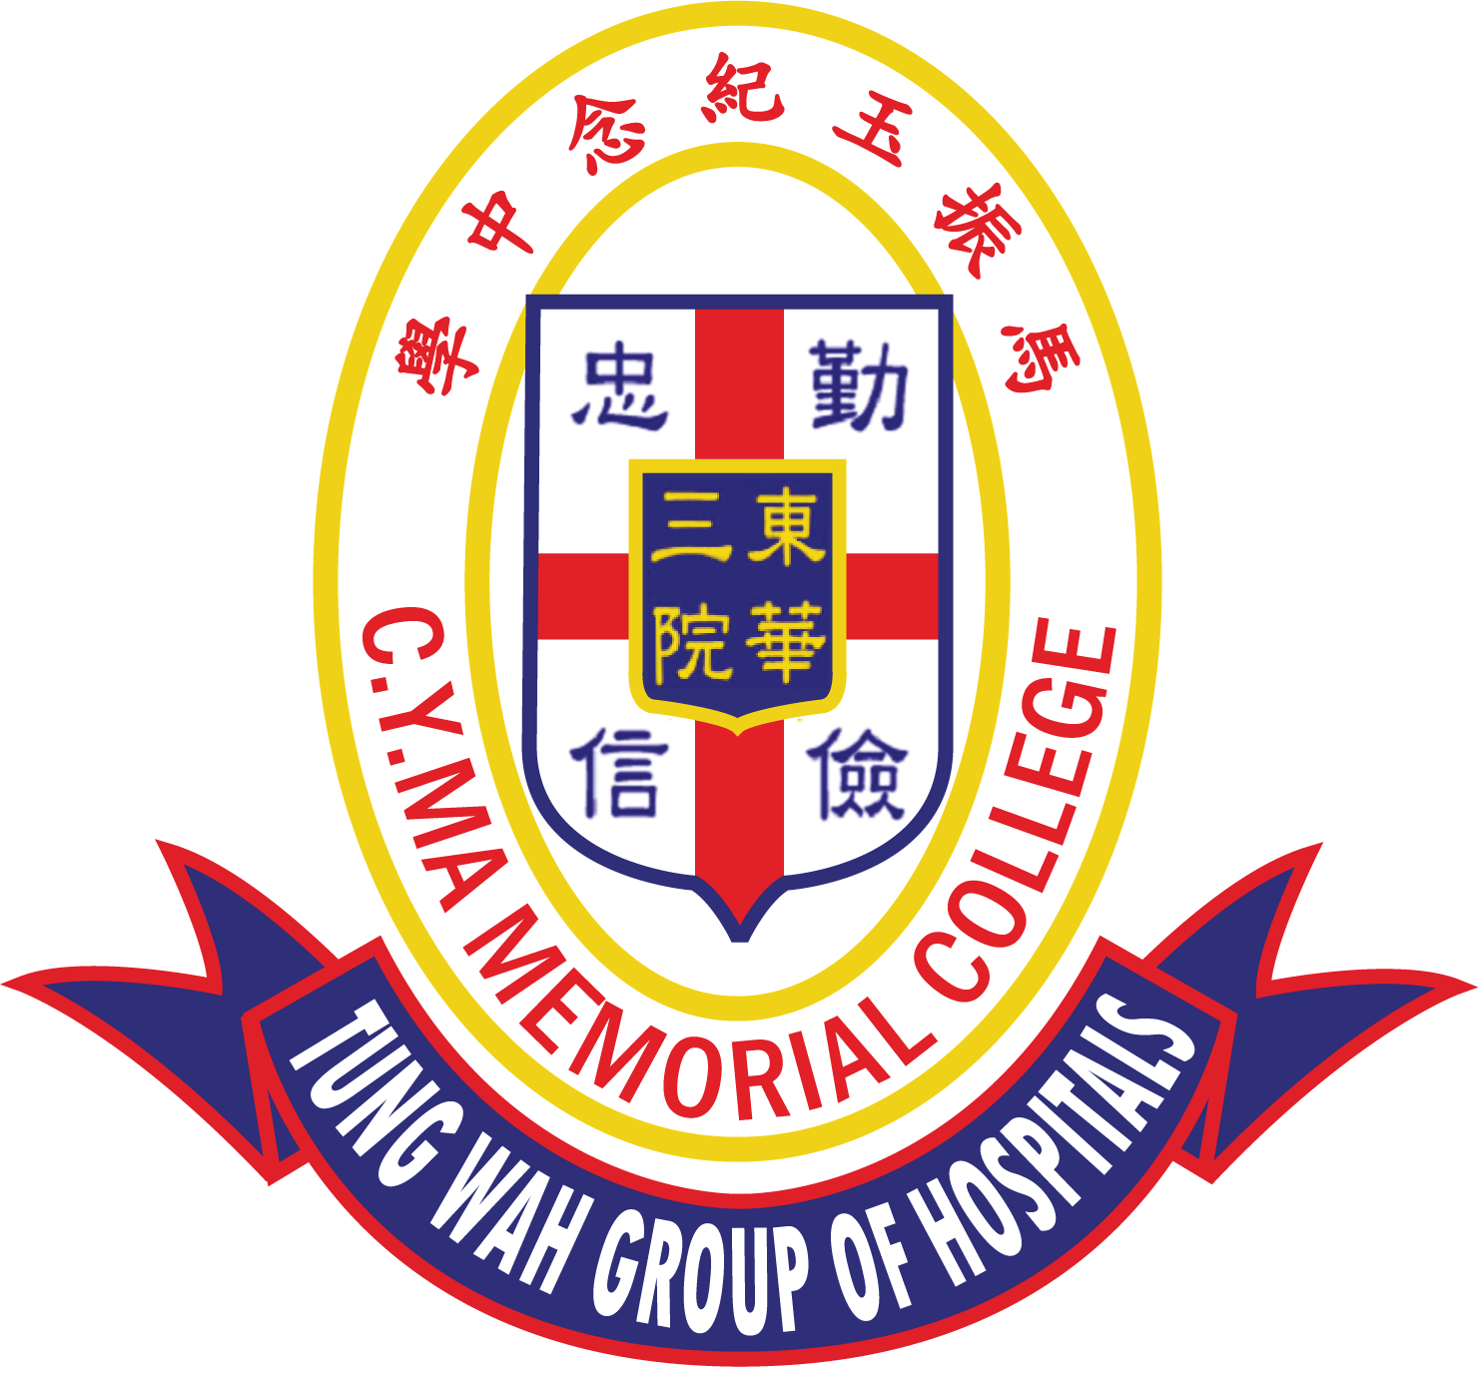
The 6th C.Y. Ma Culture and Arts Youth Elites Tournament
English Speaking Contest
Competition Guidelines
Objectives:
- To promote English learning and to enhance students’ English speaking skills and creativity.
- To help students build confidence in public speaking and boost their self-esteem.

Details:
Topic: ‘ I want to be …’
Deadline for video submission: 17th February 2023 (Friday)
Prize Presentation Day: 4th March 2023 (Saturday)

Participants:
- Primary 5 or 6 students. Each school can enter a maximum of three contestants.
- A teacher/parent should accompany their students to the prize presentation ceremony.

Content of Contest:
- Students should submit a video of a speech about 2 minutes on the given topic.
- Competitors shall follow the below order in recording the video:
(i) Announce their names and classes.
(ii) Announce the title.
(iii) Perform the whole piece once.
- The video must be a single, continuous shot video footage. Competitors must not stop or pause the camera during shooting.
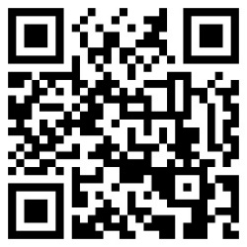
- Special effects (such as filters, transitions, colour adjustments, light adjustments or subtitles etc.), mixing, editing or post-production are not permitted.
- The video must be recorded live and dubbing is not permitted.
- Earbuds / in-ear headphones as sound receivers are not allowed.
- The resolution of the video should be 720p (1280x720) or above.

Application: application form
Fill in the Google Form and upload the video on or before 17th February 2023 (Friday).
Winners will be notified by email on or before 24th February 2023 (Friday).

Criteria for assessment:
Content (Ideas and Organization; Creativity) | 30%
Language (Vocabulary and Grammar) | 30%
Voice (Volume, Fluency, Intonation, Pace) | 20%
Appearance (Stage performance / Body gestures / Eye Contact) | 20%

Prizes:
Trophies will be given to First, Second, Third places; and a Certificate of Participation to every contestant.

Enquiries:
Contact Person: Miss Mabel Lam Telephone: 2443 9833 Fax: 2443 2882
Email: lamsoyuet@cyma.edu.hk Address: 3 Yau Sin Street, Au Tau, Yuen Long, N. T.

