TWGHs C.Y. Ma Memorial College
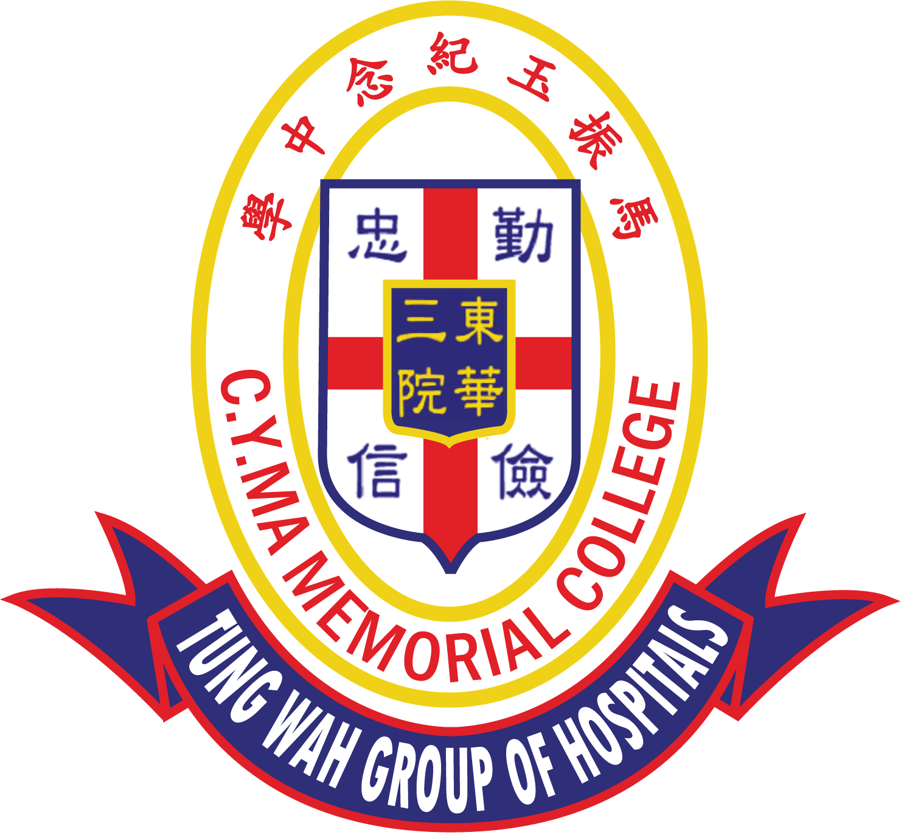
The 6th C.Y. Ma Culture and Arts Youth Elites Tournament
Chinese & English Penmanship Competition
Entry Form

English Section (P.5 – P.6)
All entries should be sent by the school, please check and submit:

- the completed entry form(s) (a maximum of 3 entries for each school); and
- the completed application form.

Please refer to the competition guidelines for details.

Template

Some Inspiration by Catherine Pulsifer

Need some inspiration
Look back over the generations
Read about people who
Difficult times they went through.
We sometimes think we have it bad
We feel down and so sad
But yet when you look and see
What others accomplished, what we could be.
Read a biography or two
It will give you ideas of what to do
When you are feeling defeated and
Up against many demands.
Life lessons others have had
Can be our launching pad
Be inspired don't be blue
You can achieve success too!

Please write on the next page

TWGHs C.Y. Ma Memorial College
The 6th C.Y. Ma Culture and Arts Youth Elites Tournament
Chinese & English Penmanship Competition-- English Section (P.5 – P.6)

Student’s Name: (English) ___________________________ (Chinese) _________________
Class: _______ School Name: __________________________________________________

Complete the penmanship below using a black ball-pen.

