TWGHs C.Y. Ma Memorial College
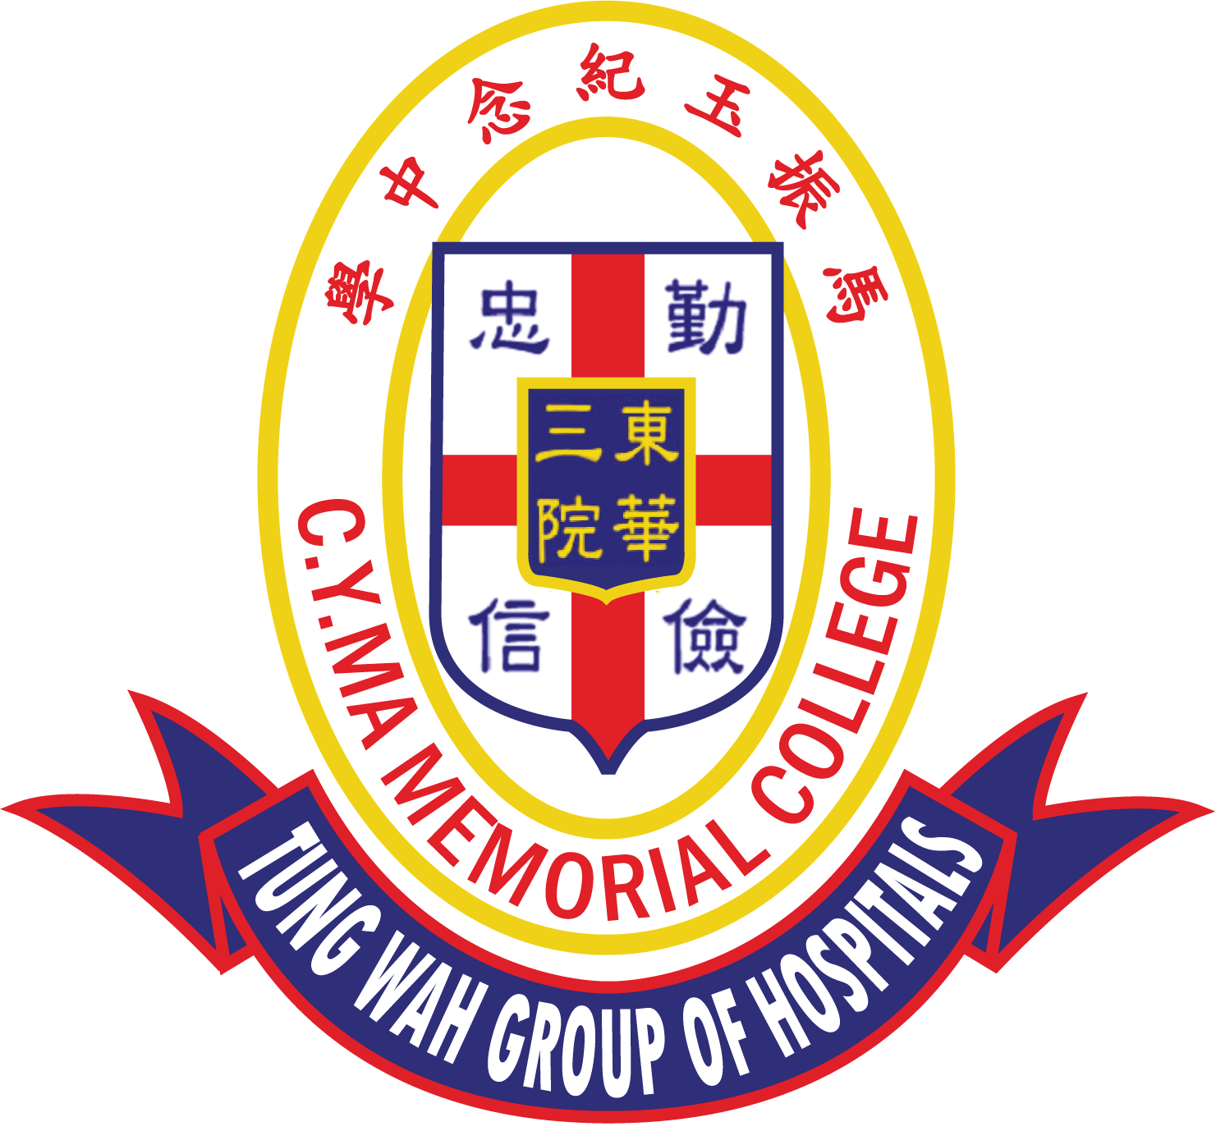
The 6th C.Y. Ma Culture and Arts Youth Elites Tournament
English Penmanship Competition
Competition Guidelines

Objectives:
- To promote the appreciation of Chinese and English penmanship.
- To encourage students to write neatly and clearly.

Details:
Theme: Positive Life

Round 1
- Entries must be completed on the official entry form and application form and sent to the school on or before 17th February 2023 (Friday).
- Photocopies of the entry form will be accepted.
- Each school should enter a maximum of three contestants from Primary 5 to Primary 6.

Round 2 (Final Competition)
Date: 4th March 2023 (Saturday)
Time: 10:00am – 12:00pm
Venue: TWGHs C.Y. Ma Memorial College

- Shortlisted contestants will be notified by email on or before 24th February 2023 (Friday), to attend the penmanship final competition and prize-giving ceremony on 4th March 2023 (Saturday).
- Each contestant should bring a black ball-pen to take part in the final.
- A teacher or a parent should accompany the contestants to the final.

Criteria for assessment:
English Section
Letter and Word Formation | 50%
Spacing | 10%
Alignment | 10%
Accuracy (Spelling & Punctuation Marks) | 10%
Overall Presentation | 20%

Prizes:
Prizes will be given to First, Second, Third places; and a Certificate of Merit to every shortlisted contestant.

Enquiries:
Contact Person: Miss Mabel Lam
Telephone: 2443 9833 Fax: 2443 2882
Email: lamsoyuet@cyma.edu.hk
Address: 3 Yau Shin Street, Au Tau, Yuen Long, N.T.

